Calamari Printer Project
Product Description:
The Calamari is a tiny (slightly larger than a computer mouse), portable, self-propelled, single-color printer intended for printing anywhere. Using an infrared interface compatible with standard lap-tops, PDA’s, or other computers, the Calamari will print on any size rectangular paper (or other suitable medium) sitting on a flat, smooth, level surface.

The Calamari will take five to ten seconds to initialize by determining the positions of all four corners. A 300 dot per inch print of text and graphics on letter (or A4) paper will take under one minute to complete. A set of four AA-size batteries will power the Calamari for at least one hour of printing, and the device, including batteries, will weigh 500 grams (~ ½ lb.) or less.

Project Objective:

Develop Calamari and release the product in eight months (by June 30, 2012) with 12 full-time contributors. Priorities:
Least flexible (Constrain) Schedule
Moderately flexible (Optimize) Scope
Most flexible (Accept) Resources

Roles:
- Research and Development (R&D): Develop the product and create a working prototype.
- Learning Products (LP): Complete training, support and reference materials.
- Marketing (Mrk): Assess market situation and user needs, recommend solution, launch product.
- Manufacturing (Mfg): Set up for and produce the product in quantity.
- Finance (Fin): Provide financial analysis of costs, pricing, projected profit.

Using the "PERT" style network diagram and work breakdown structure (pages 3-5) supplied and the information below, fill in pessimistic and optimistic estimates for the project tasks. The estimates already entered are "most likely".

1. The tasks assigned to Finance are all things they have done before and their estimates are usually accurate to within a day.

2. There is a lot of data supporting the tasks of printing documents and preparing marketing materials. These estimates are considered very accurate.

3. R&D is well-staffed with experienced people. You are confident of all the Development task estimates, plus or minus 5%, except for electronic design. This project requires known software and controls, with which the team is very familiar, but miniaturization of the hardware is a new challenge. This work may take as much as an extra couple of weeks beyond the estimate given.

4. Learning Products people are currently very busy completing work for the “TVDinner” product, which is currently the highest priority project. Their estimates assume no higher priority work will conflict with Calamari. Even so, the tasks assigned to them are very unlikely to be completed more than a day early, and this group has a number of very inexperienced people. Slipping Development Phase LP estimates by as much as a third is likely, but Investigation Phase estimates seem fine.

5. Marketing has already started the needed research and has made a firm commitment to completing all market research and other Investigation-phase tasks on time. Market research may be completed a week early.

6. All functional areas understand how important the review of LP output is to the success of Calamari, and although no one has promised to take less time than the estimate, everyone believes the time for this will be sufficient.

7. Manufacturing reports that they expect to have no difficulty in moving Calamari into production. Several engineers from a division experienced in similar production are assigned to work on Calamari. The only estimate that they are not too confident of is the time for ordering parts, as new suppliers will be used for the infrared interface hardware. They think this task might take as much as an additional three weeks. All the other estimates for the project seem accurate within a day or so.

8. The mini digital stepping motor research is the only task assigned to R&D in the Investigation phase that seems risky. This may require an extra week, but the other estimates are good.

9. Marketing expects several other projects to start up during the Development phase of Calamari. They report that their tasks of writing the marketing plan and product launch will not be finished earlier than estimated and both of these tasks may take up to two extra weeks due to higher priority conflicts.

Given this information, identify the tasks off the critical path that are most likely to cause project slippage. Consider any sequences of tasks that could cause the Manufacturing Release (MR) milestone to slip.

Determine a worst case Calamari schedule for group discussion.

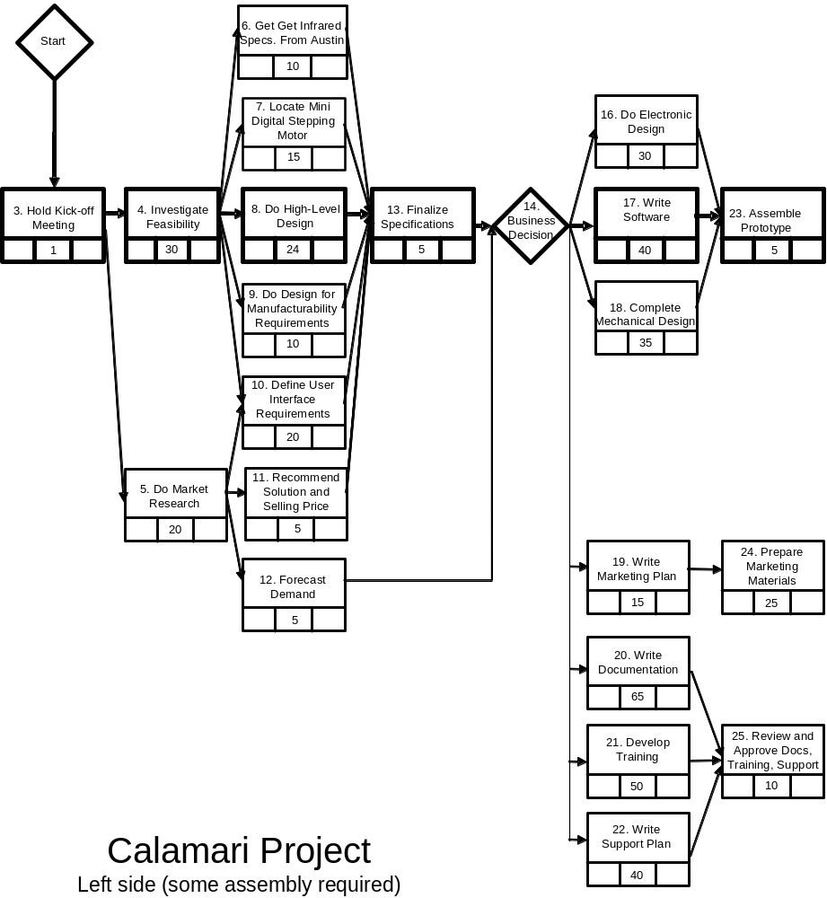
Most likely estimate
Optimistic estimate
Pessimistic estimate



